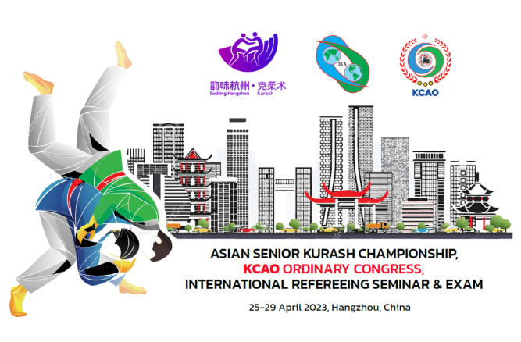

APPLICATION FORM
for official accreditation and visa at the XII ASIAN SENIOR KURASH CHAMPIONSHIP
25-29 APRIL 2023
At Hangzhou city, CHINA

PLEASE FILL IN AND SEND THIS APPLICATION AND PASSPORT COPY BEFORE 20 MARCH 2023
TO : huxl@hangzhou2022.cn , info@kurash-kcao.org

Federation information
Name of Federation
Name of Federation President
Contact telephone with codes
Email
Address

Status | Given Name | Surname | Date of Birth  (d/m/y) | Citizenship | Passport No. | Date of issue  (d/m/y) | Expiry date  (d/m/y)
Team leader
Coach
Referee
Referee
Male -60 kg
Male -66 kg
Male -73 kg
Male -81 kg
Male -90 kg
Male -100 kg
Male +100 kg
Coach
Female -48 kg
Female -52 kg
Female -57 kg
Female -63 kg
Female -70 kg
Female -78 kg
Female -87 kg
Female +87kg
Others
Others

